**20ITE03 – User Interface Design**

**MINI-PROJECT**

**WEBSITE FOR PLACEMENT CELL**

**Landing Page:**

## 

**STUDENT LOGIN**



**STUDENT REGISTER**



**FACULTY LOGIN**



**FACULTY REGISTER**

**DETAILS EDIT PAGE**

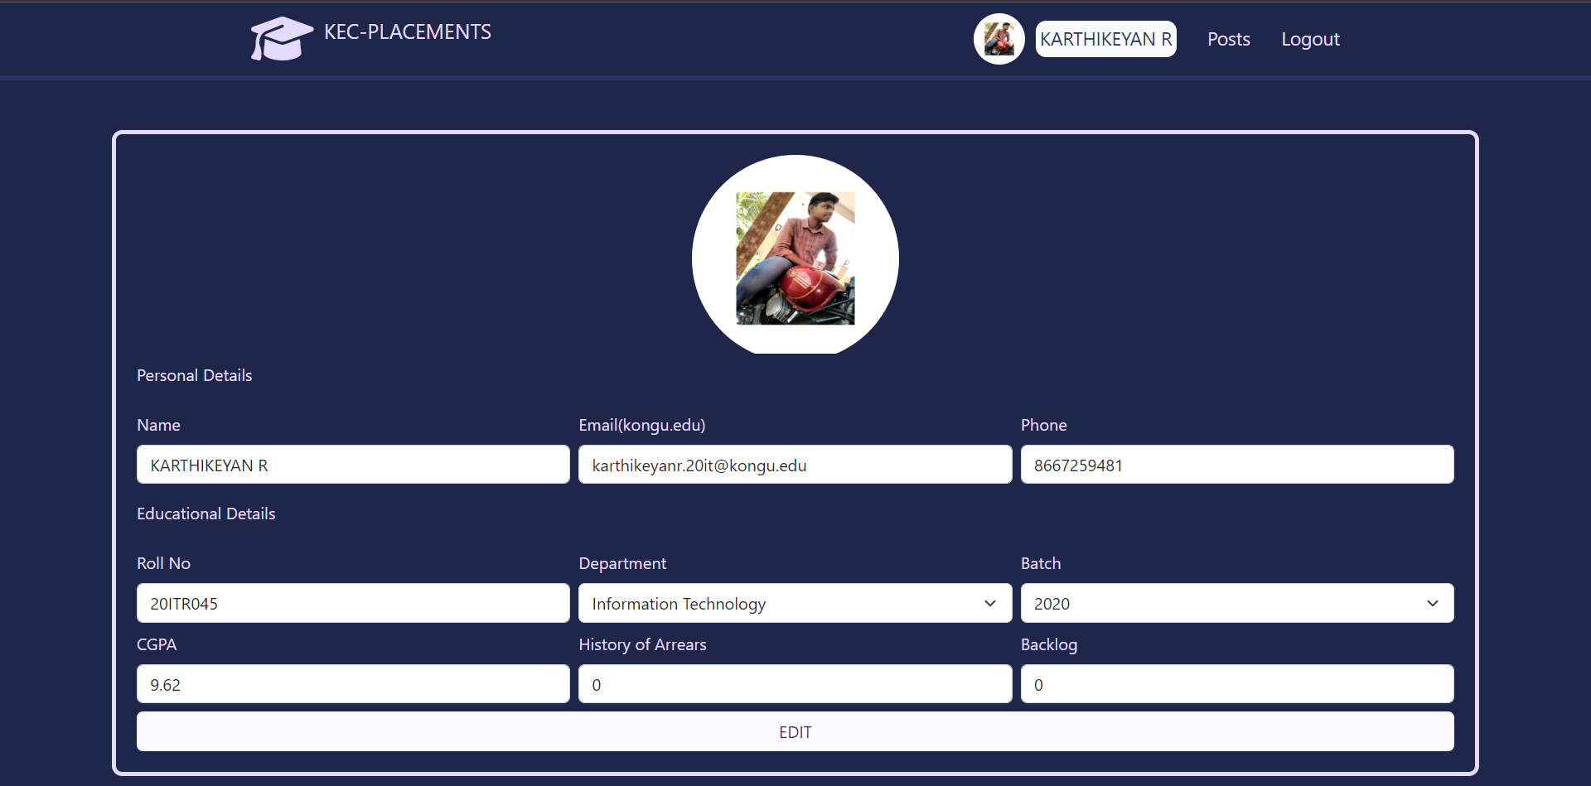

**POST PAGE**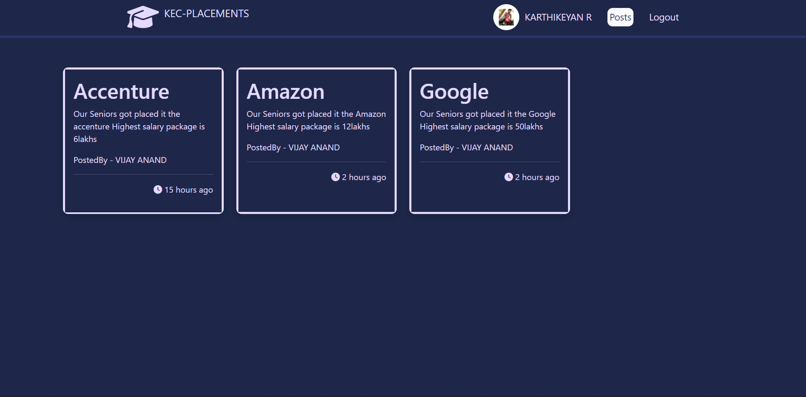

**ADMIN REPORT PAGE**

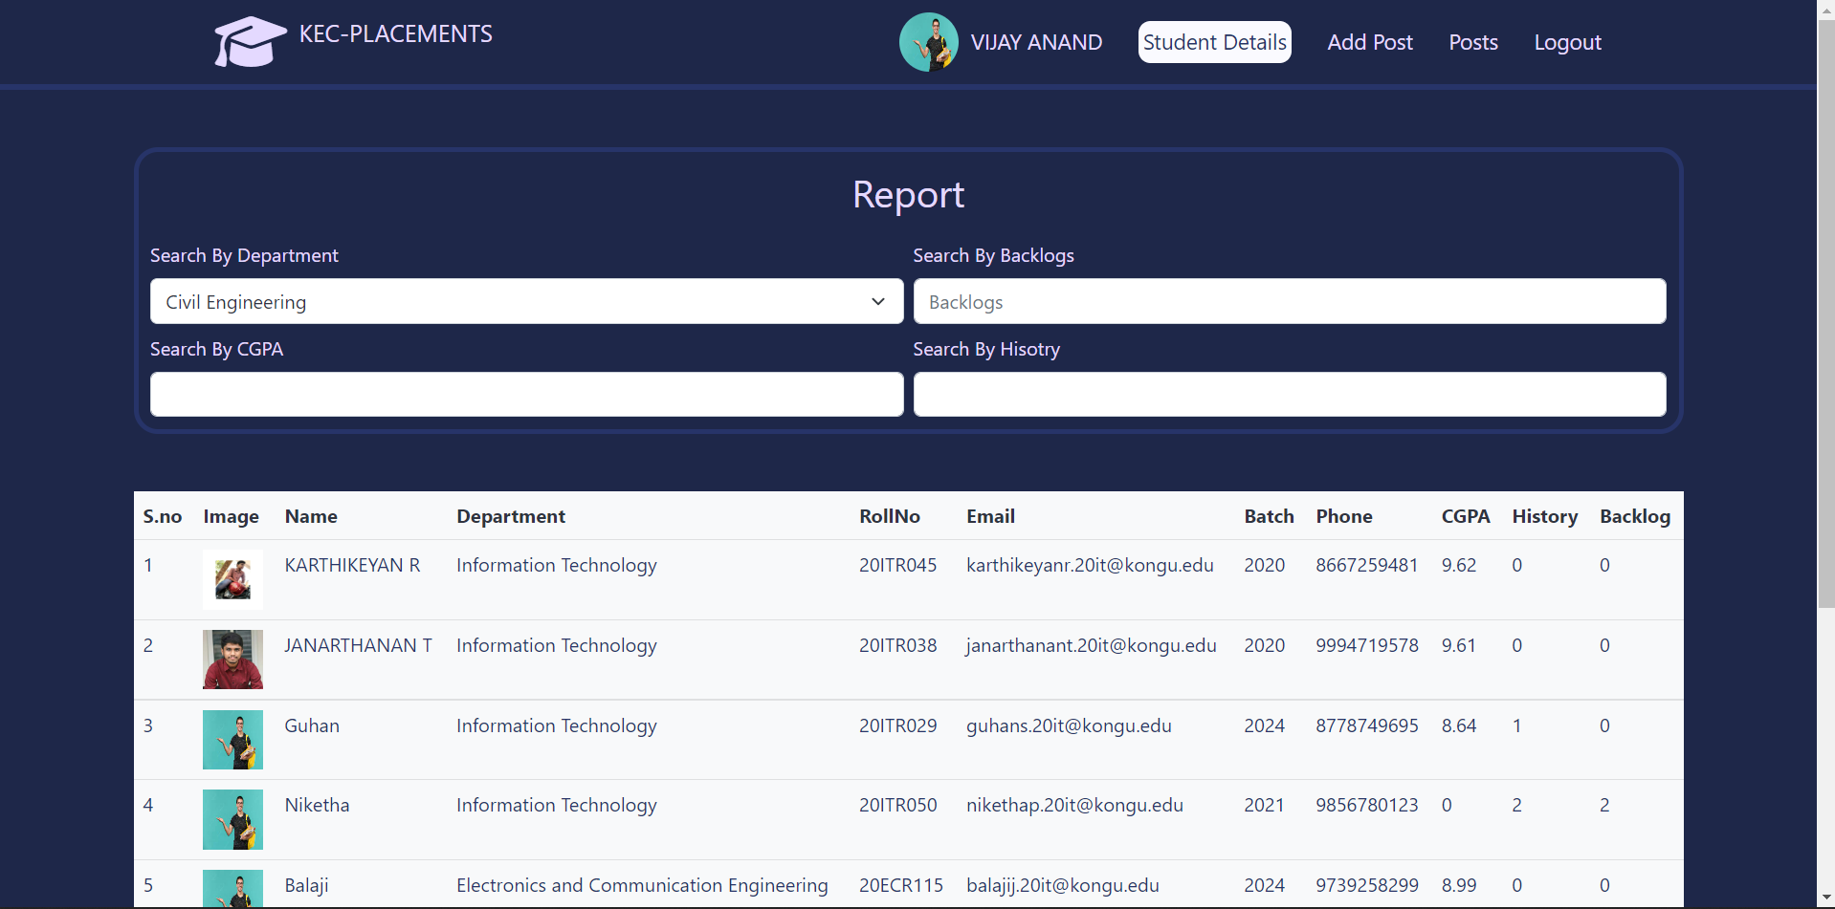

**ADMIN POST PAGE**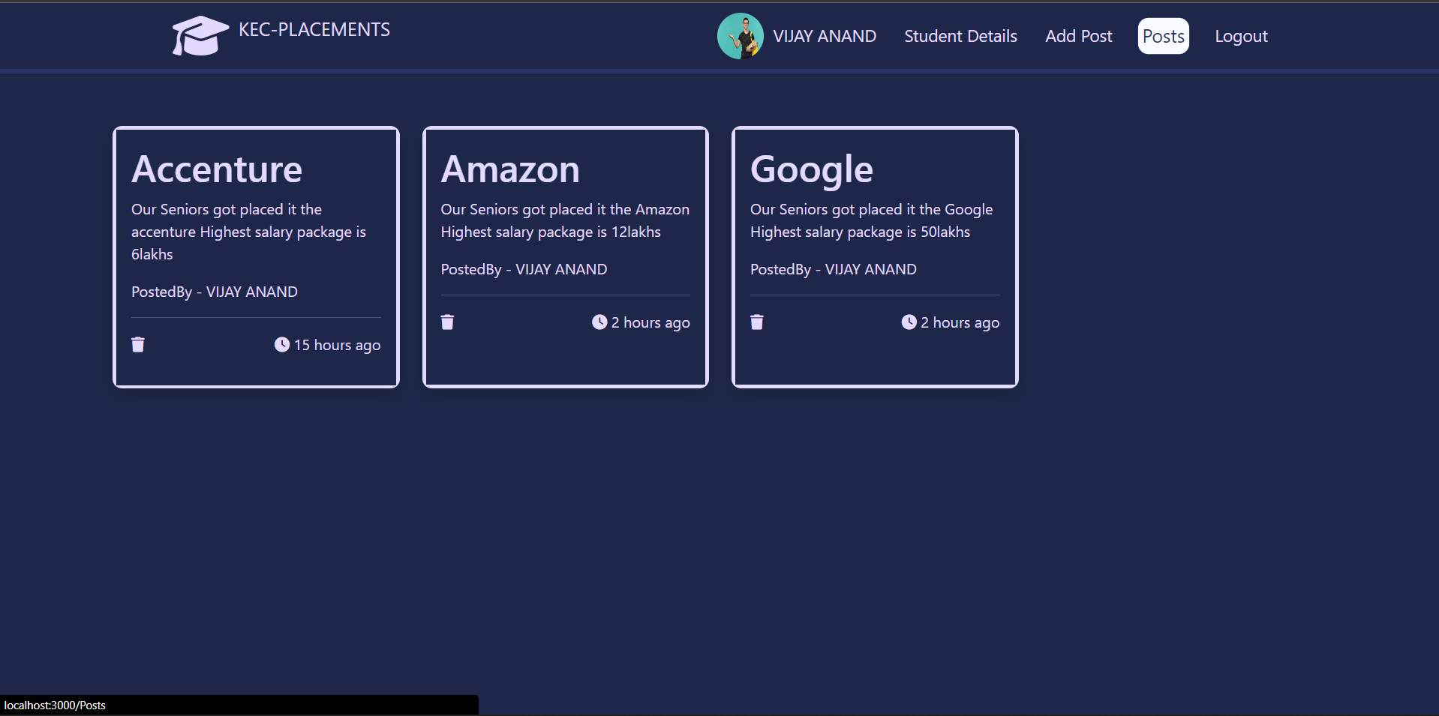

**DONE BY**

**GUHAN S 20ITR029**

**KARTHIKEYAN R 20ITR045**